Technical Requirements Document (TRD)

Project: SmartChef — AI-Powered Recipe & Meal Planning Assistant
Version: 2.0 (React frontend + image search) Author: [Your Name] Date: [Submission Date]

1. Architecture Overview
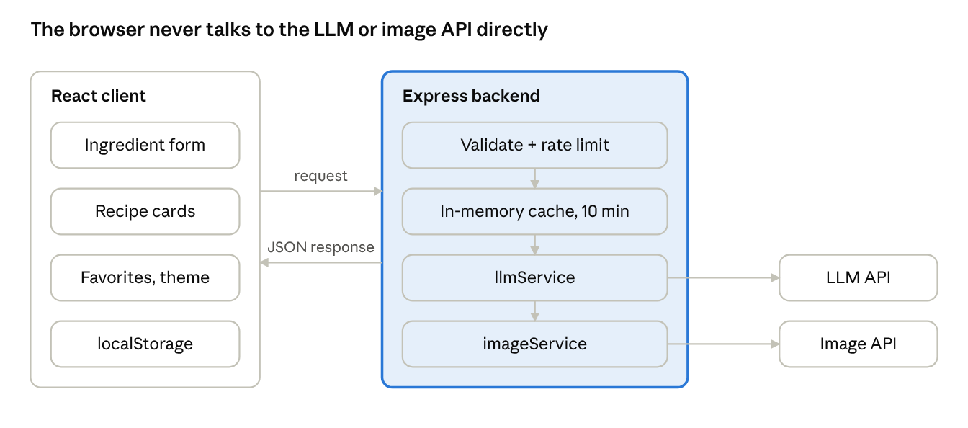
architecture · React client, Express backend, 2 external APIs
Requests pass through validation, rate limiting and the cache before the LLM and image lookups; both API keys stay on the server.
Key architectural decision — No Database:
- Client-side state (favorites, search history, theme) is stored in localStorage, scoped per-browser, managed through React state + context. This is acceptable because the app has no login/multi-device requirement in v1.
- Server-side state is limited to a short-lived in-memory cache (keyed by a hash of ingredients + filters + servings) to avoid duplicate LLM and image API calls. This cache is intentionally volatile — it resets on server restart, which is fine since it's a cost/performance optimization, not a source of truth.

2. Tech Stack
Layer | Technology | Reason
Frontend | React (Create React App or Vite), CSS (Flexbox/Grid, CSS Modules or plain CSS) | Component-based UI, reusable recipe cards, cleaner state management than vanilla JS
Backend | Node.js + Express.js | Lightweight server to securely proxy LLM and image API calls
LLM Integration | OpenAI API / Google Gemini API / Anthropic Claude API (pick one) | Powers recipe generation
Image Integration | Unsplash API or Pexels API (free tier) | Fetches a relevant photo per recipe title
Caching | In-memory Map or node-cache npm package | Avoids redundant LLM/image calls, no DB needed
Rate Limiting | express-rate-limit | Prevents API abuse / cost overrun
Env Management | dotenv | Keeps API keys out of source code
Client Storage | localStorage (read/written via a small React hook, e.g. useLocalStorage) | Persists favorites/history without a database
Deployment (optional) | Frontend: Netlify/Vercel; Backend: Render/Railway | Free-tier friendly, separates concerns

3. Folder Structure
smartchef/
├── client/ # React app
│ ├── src/
│ │ ├── components/
│ │ │ ├── IngredientForm.jsx
│ │ │ ├── RecipeCard.jsx
│ │ │ ├── RecipeList.jsx
│ │ │ ├── FavoritesTab.jsx
│ │ │ └── ThemeToggle.jsx
│ │ ├── hooks/
│ │ │ ├── useLocalStorage.js
│ │ │ └── useRecipeApi.js
│ │ ├── context/
│ │ │ └── ThemeContext.jsx
│ │ ├── App.jsx
│ │ └── index.jsx
│ └── package.json
├── server/
│ ├── server.js # Express app entry point
│ ├── routes/
│ │ └── recipe.js # /api/generate-recipe route
│ ├── services/
│ │ ├── llmService.js # builds prompt, calls LLM API
│ │ └── imageService.js # calls Unsplash/Pexels API
│ ├── middleware/
│ │ ├── rateLimiter.js
│ │ └── validateInput.js
│ ├── utils/
│ │ └── cache.js # in-memory cache logic
│ ├── .env # LLM_API_KEY, IMAGE_API_KEY (never committed)
│ └── package.json
└── README.md

4. API Design

Endpoint: POST /api/generate-recipe
Request Body:
{
"ingredients": ["rice", "tomato", "onion"],
"diet": "vegetarian",
"servings": 2
}
Success Response (200):
{
"success": true,
"recipes": [
{
"title": "Tomato Onion Rice",
"time": "25 mins",
"calories": 320,
"imageUrl": "https://images.unsplash.com/photo-xxxx",
"ingredients": [
{ "name": "Rice", "quantity": "1 cup" },
{ "name": "Tomato", "quantity": "2 medium" },
{ "name": "Onion", "quantity": "1 medium" }
],
"steps": [
"Cook rice separately and set aside.",
"Saute onions until golden, add tomatoes and cook until soft.",
"Mix in cooked rice and season to taste."
]
}
],
"cached": false
}
Error Response (4xx/5xx):
{
"success": false,
"error": "Ingredient list cannot be empty."
}

Backend Processing Steps
- validateInput middleware checks ingredients array is non-empty, length-limited, and free of malicious content.
- rateLimiter middleware checks request count per IP.
- Generate a cache key: hash(ingredients.sort().join(',') + diet + servings).
- If cache hit → return cached response with cached: true.
- If cache miss → build a structured prompt and call the LLM API via llmService.js.
- Parse/validate the LLM's JSON response before using it.
- For each recipe title, call imageService.js to fetch a matching photo URL from Unsplash/Pexels; attach it as imageUrl. If the image fetch fails, fall back to a placeholder image URL — never fail the whole request over a missing photo.
- Store the combined result in cache with a TTL (e.g., 10 minutes).
- Return JSON to the React client.

5. LLM Prompt Design (Core Technical Piece)
The backend constructs a prompt similar to:
You are a recipe assistant. Given these ingredients: {ingredients},
dietary preference: {diet}, and servings: {servings}, suggest 2 recipes.
Respond ONLY with valid JSON in this exact structure (no extra text):
{
"recipes": [
{
"title": "string",
"time": "string",
"calories": number,
"ingredients": [{"name": "string", "quantity": "string"}],
"steps": ["string"]
}
]
}
Why this matters for the interview: structured, constrained prompting (asking for JSON only, defining the schema explicitly) is a real prompt-engineering technique to make LLM output reliably parseable — be ready to explain this and what happens if parsing fails (fallback error message, do NOT crash the server).

6. Image API Integration
- After the LLM returns recipe titles, imageService.js calls Unsplash's (or Pexels') search endpoint with the recipe title as the query (e.g., "Tomato Onion Rice food").
- The first relevant result's image URL is attached to that recipe object as imageUrl.
- The image API key is stored server-side only, same as the LLM key — the React frontend never calls Unsplash/Pexels directly.
- Image fetches are cached alongside the recipe (same cache entry), so a cached recipe response doesn't re-fetch the image either.
- Failure handling: if the image API errors or returns no results, the backend attaches a static placeholder image URL so the frontend never breaks.

7. React Frontend Architecture
- Component breakdown:
  - IngredientForm — controlled inputs for ingredients, diet, servings; calls the API hook on submit
  - RecipeList — maps over returned recipes and renders a RecipeCard per recipe
  - RecipeCard — displays image, title, time, calories, ingredients, steps, and a Save button
  - FavoritesTab — reads saved recipes from localStorage via useLocalStorage and renders them the same way
  - ThemeToggle — reads/writes theme preference via ThemeContext
- State management: Local component state (useState) for form inputs and API results; React Context for theme; a custom useLocalStorage hook to sync favorites/history/theme to the browser.
- API calls: Centralized in a useRecipeApi hook wrapping fetch, so loading/error/data states are handled in one place and reused across components.
- No external state library needed (Redux/Zustand) — app state is simple enough for Context + hooks, which is also easier to defend in an interview as a deliberate, right-sized choice.

8. Caching Strategy
- Use node-cache or a simple Map with manual TTL tracking.
- Cache key = hash of normalized request (sorted ingredients + diet + servings).
- TTL: ~10 minutes — long enough to catch duplicate demo requests, short enough that data doesn't go stale if the LLM/prompt or image results change.
- This is explicitly not a substitute for a database — it is a performance/cost optimization layer only, with no guarantee of persistence.

9. Security Considerations
- API key protection: LLM API key and image API key live only in the backend .env file, accessed via process.env. Neither is ever included in any response sent to the client.
- Input validation & sanitization: Reject empty/overly long ingredient lists; strip any HTML/script-like content before including user input in the prompt (basic prompt-injection hygiene).
- CORS: Configure Express CORS to only allow requests from the deployed React frontend origin.
- Rate limiting: Protects against abuse and runaway API costs across both the LLM and image APIs.
- No sensitive data stored: Since there's no DB and no login, there's no user PII to protect beyond what's in localStorage (which never leaves the user's browser).

10. Error Handling & Logging
Scenario | Handling
LLM API times out | Return 504 with friendly message: "AI service is taking too long, please try again."
LLM returns invalid JSON | Catch parse error, log server-side, return 502 with generic error message
Image API fails or returns no results | Attach placeholder image URL, do not fail the request
Empty/invalid input | Return 400 with specific validation message
Rate limit exceeded | Return 429 with "Too many requests, please wait a moment."
Unexpected server error | Global Express error-handling middleware returns 500, logs stack trace server-side only

11. Testing Strategy
- Manual testing: Test with valid ingredients, empty input, very long input, special characters, and unsupported diet values.
- API testing: Use Postman/Thunder Client to test /api/generate-recipe directly, independent of the React frontend.
- Cache verification: Send the same request twice and confirm the second response has cached: true and returns faster.
- Rate limit verification: Send rapid repeated requests and confirm a 429 is eventually returned.
- Component testing: Render RecipeCard with mock data to confirm it displays correctly, including a missing-image fallback case.
- Cross-browser/responsive testing: Chrome, Firefox, mobile viewport via DevTools.

12. Deployment (Optional but recommended for demo)
- Frontend: Build the React app (npm run build) and deploy static files to Netlify or Vercel.
- Backend: Deploy Express server to Render or Railway (free tier), with LLM_API_KEY and IMAGE_API_KEY set as environment variables in the hosting dashboard — never in code.
- CORS config: Update allowed origin to the deployed React frontend URL.

13. Anticipated Interview / Viva Questions (Prep Appendix)
- Why no database? — Explain localStorage for client persistence + in-memory cache for server optimization; discuss what would change if you added one (MongoDB for saved recipes across devices).
- How do you keep the LLM and image API keys secure? — Backend-only .env, never exposed to client; all external calls proxied through your Express server.
- What happens if the LLM returns malformed JSON? — Explain try/catch around JSON.parse, fallback error response, why constrained prompting reduces this risk.
- Why fetch images separately instead of asking the LLM for an image? — LLMs generate text, not real photos; a dedicated image search API returns actual relevant photos, more reliable and cheaper than image generation.
- How does your caching work, and why is it not persistent? — Explain TTL-based in-memory cache, cache key construction, and that it's a performance layer, not a data store.
- Why React instead of vanilla JS? — Component reusability (RecipeCard reused in results and favorites), cleaner state management via hooks/context, easier to extend.
- How do you prevent abuse of your API keys/costs? — Rate limiting per IP, input length limits, caching to reduce duplicate calls to both the LLM and image APIs.
- What is prompt injection, and did you guard against it? — Explain sanitizing user input before inserting into the prompt template.
- How would you scale this to production? — Add DB for persistence, add auth, move cache to Redis (shared across server instances), add proper logging/monitoring.
- Walk me through what happens end-to-end when a user clicks "Generate Recipes." — Be ready to narrate the full flow from the React form submit through the API design and image integration sections above.

